**Procedures for Microsoft Teams Virtual Class**

**Step 1: Log onto Office 365 to find your class team**

1. Log onto the Bohn Elementary home page: <https://bohn.tracy.k12.ca.us/>

2. Click on **Students tab** (upper right corner).

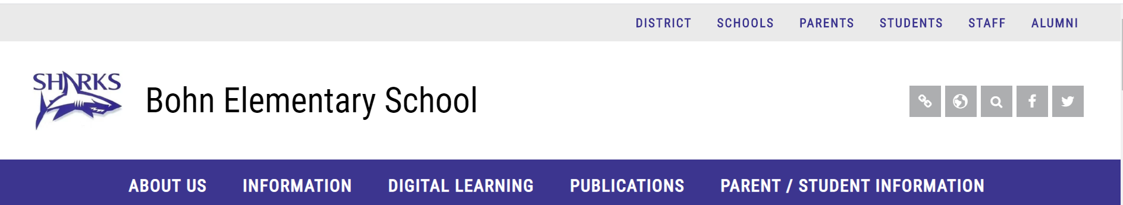



3. Select **Office 365 login tab.**

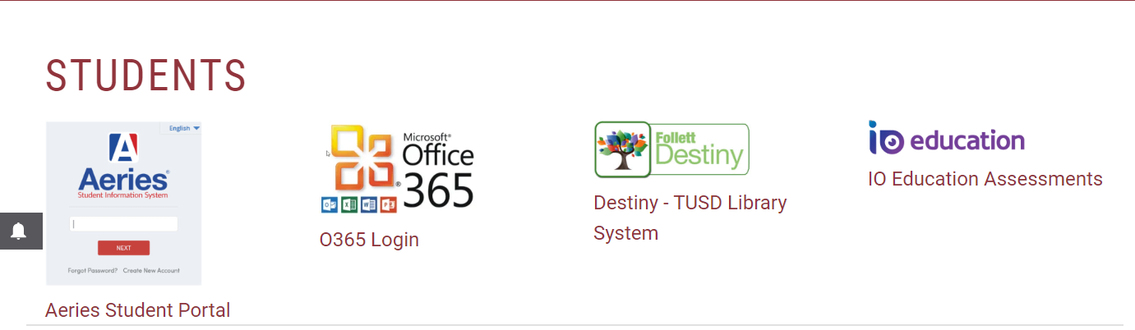



4. Enter your TUSD email which is:

* **ID number@student.tusd.net** ( 12345678 @student.tusd.net)
* Your ID number can be found in aeries

5. Enter password

Note: All passwords will be changed to your birthdate on August 3, 2020.

Example : MMDDYYYY 08112020

6. Now you will find your office **365 applications.**

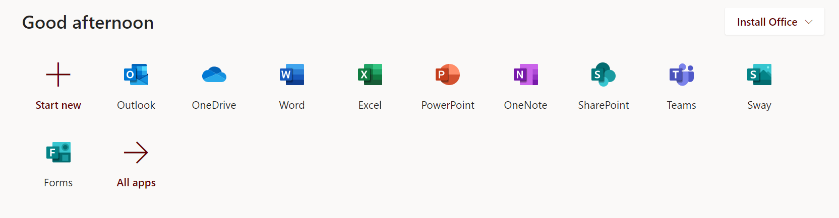



7. Click on the **Teams option** and find your teacher’s Team site.

(you can download the Teams app and pin it to your task bar if you like)

**Step 2: Understanding Teams**

1. Under the Teams class logo you will see the word **General**. General is like your home page.

All info for the class will be in the **General posts.**

2. Across the top, you will notice tabs (**Posts, Files, Class notebook, Assignments, and Grades.**

3. On the sidebar to the left your will see more tabs (**activity, chats, teams, assignments, and calendars).**

4. Any time a Teacher schedules a class meeting, assign homework, or give directions, you will see it in the **General post** section.

**Step 3: Facetime Class Team Meetings (similar to zoom)**

1. C**lass team meetings** will be starting at 8:15am everyday Synchronize.

2. Check the general posts, calendar, or activity bell alerts for dates and time to **“join Microsoft teams meeting” (**similar to zoom).

3. Once in the meeting, the Teacher will be able to **share her screen** with you and give class lessons, answer questions, and **support you**.

**Step 4:** **Assignments, Turning in Work, and Grades**

1. To find assignments and attachments, click on the **assignments tab**. Assignments will also be shared in **general posts**.

2. Once you click into the **assignments**, you will see the title of the assignment, due date, point value, and reference materials.

3. After you have completed and saved your work to your computer click the **add** **work button.**

4. Select the file you want to upload and then click the **attach button.**

5. You should see your file uploaded to reference materials. Then you can click on the **Turn in** **button.**

6. your work will be sent to your teacher and you can check to see if it has been graded under the **Grades tab**.

Please feel free to watch this introduction to Teams video:

<https://www.microsoft.com/en-us/videoplayer/embed/RE4rrKE?pid=ocpVideo0-innerdiv-oneplayer&postJsllMsg=true&maskLevel=20&market=en-us>

This video is also found on the district home page.

